Table of Contents:

GIT SETUP: 2

Request GIT BASH from software Portal: 2

Install GIT BASH from software Portal: 3

Create a workspace in your laptop: 3

Data Reset scripts: 6

Access Request needed: 6

SCRIPTS 7

Selenium Data Reset script (Original): 7

Selenium Reset Scripts Updated: 8

Sample log file to reset data 9

# GIT SETUP:

## Request GIT BASH from software Portal and Install

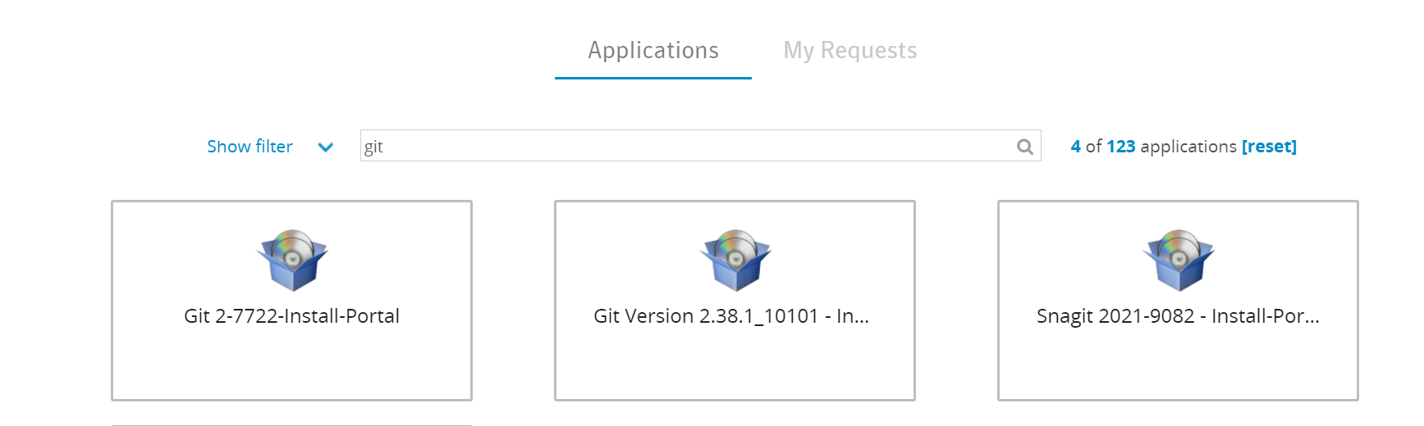

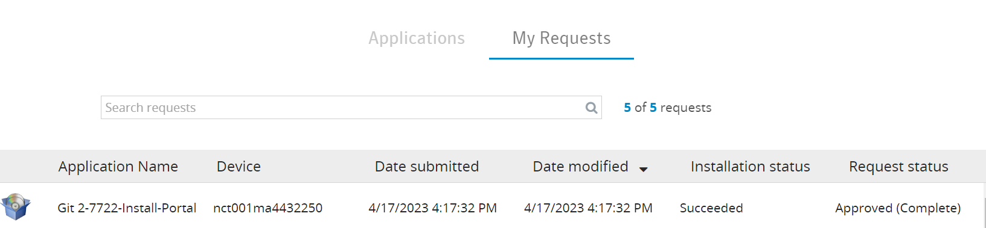

Access Git hub:

submit a Bears request to get access

GitHub: PROD USER GITHUB ENTERPRISE (GITHUB ENTERPRISE GHE)

Once Bears request got approved login to the git hub and let Melissa know she will add you to the repository.

Selenium Repository:

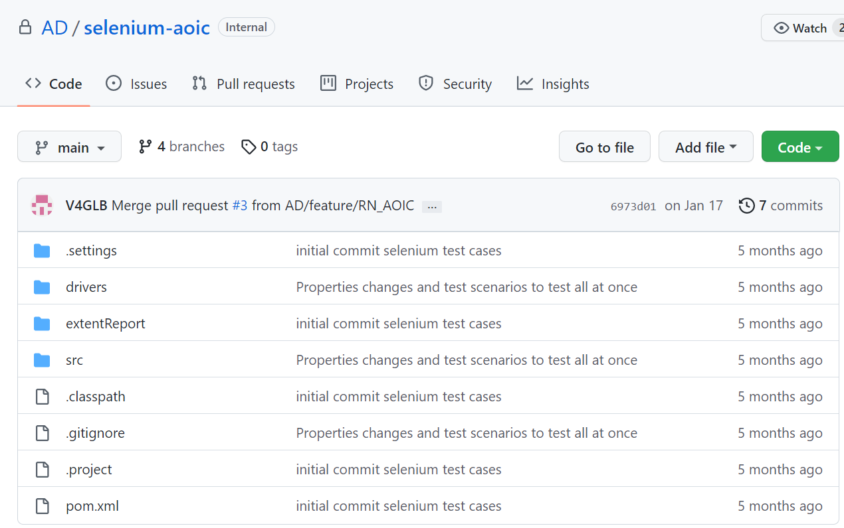

Click on branches to see the latest code:

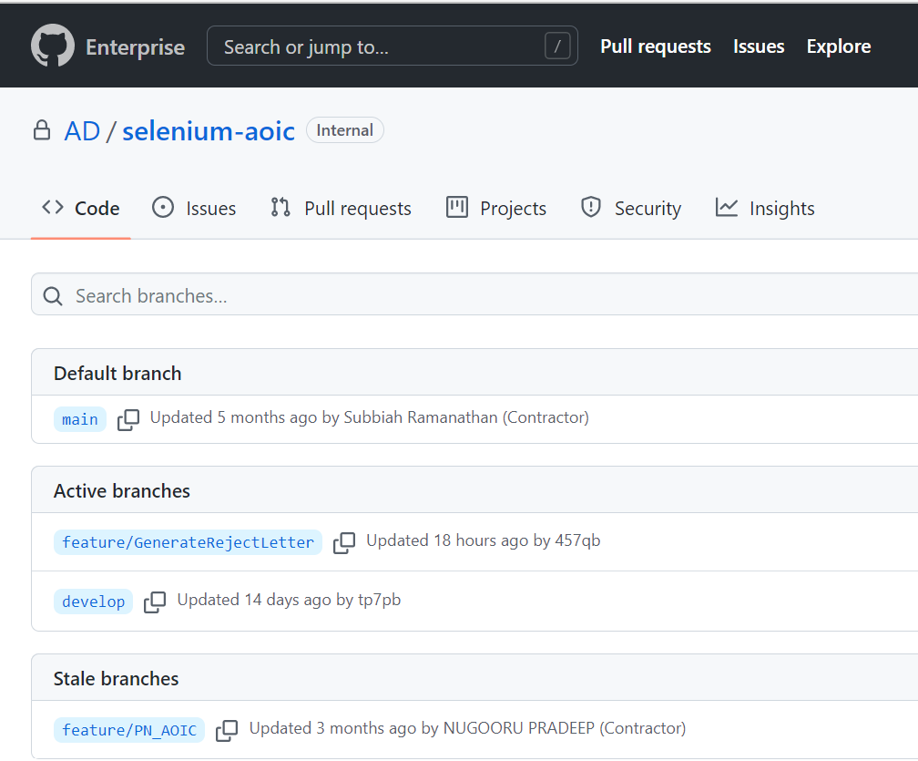

Enter commands in Git CMD to get the latest script

C:\>cd C:\Users\JZYPB\selenium-aoic

C:\Users\JZYPB\selenium-aoic>git pull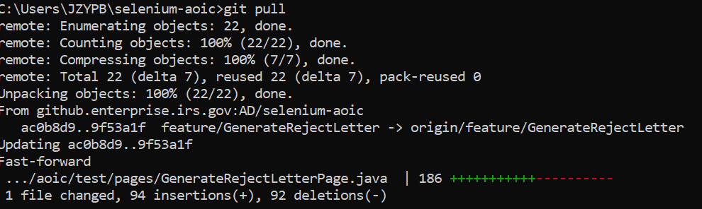

Request Eclipse Luna and install it from software portal

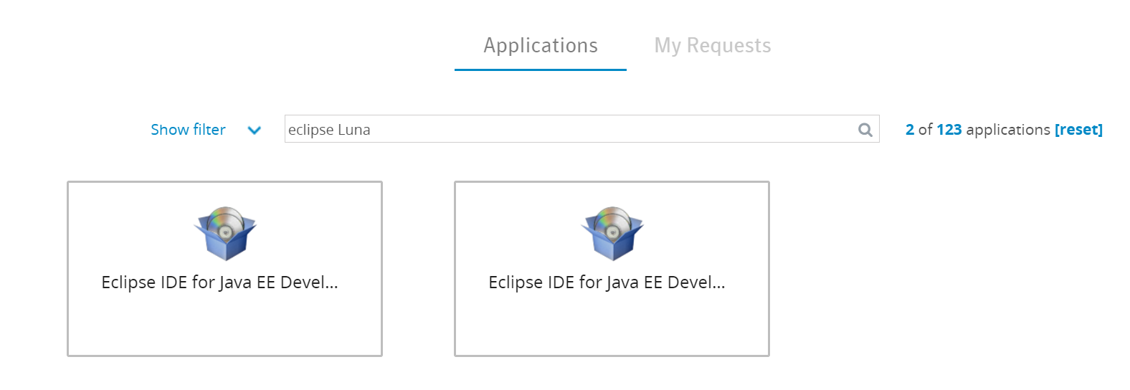



Request nexus access in Bears to get access to the User token

DEV USER NEXUS SN (INTERNAL REPOSITORY NEXUS)

Request the latest JDK Version in OS get services and install

Update username and password in settings .XML



Import Maven projects:

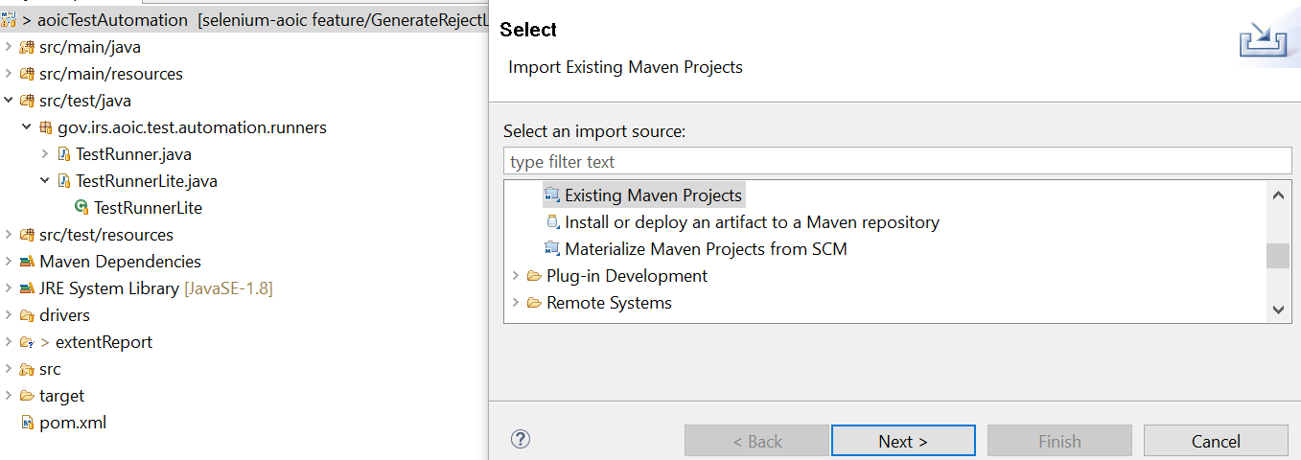

And complete the installation